Rowley Park Academy
Positive Relationships and Behaviour Policy
At Rowley Park Academy, we believe we should be values-driven where leadership at all levels has a strong moral purpose. We believe in five simple core values that underpin all that we do and characteristics that complement each one. The school talks about values regularly and how these are reflected in children's behaviour. The purpose and aim of this policy is to enable all stakeholders to create a positive, safe environment that allows all pupils to learn and reach their full potential.
FIDES
Loyalty | Tenacity | Kindness | Bravery | Brilliance
Focus on family | Insist on Excellence | Do good as you go | Embrace Innovation | Seize Success

To complement our values, the positive relationships and behaviour policy is underpinned by three main principles: Be Ready, Be Respectful, Be Safe.
BE READY | BE RESPECTFUL | BE SAFE
This principle is in reference to the children’s attitude and expectations to learning. | This principle is in reference to the children’s attitudes and behaviours towards others. | This principle is in reference to the children’s behaviours
READY TO LISTEN,  READY TO LEARN,  READY TO BE LEADERS | RESPECTFUL ATTITUDE,  RESPECTFUL WORDS,  RESPECTFUL ACTIONS | SAFE CHOICES,  SAFE ACTIONS,  SAFE SPACE
I will actively engage in my lessons.  I will use our thinking tools to be independent.  I will listen and follow instructions.  I will be a role model to others. | I will use good manners when communicating.  I will listen to and respect the opinions and beliefs of others.  I will treat others as I would like to be treated.  I will look after our school environment and resources. | I will respect personal space and boundaries of others.  I will act in a calm and considerate manner.  I will use equipment safely.  I will speak out when something or someone is unsafe.

“Classroom management is not about having the right rules, it’s about having the right relationships.”
This policy is grounded in the belief that behaviour is communicative and that every can develop the ability to self-manage and regulate their emotions and behaviour; every interaction is an intervention. We understand that part of our role is to help children understand what is right and wrong and to make the right choices.
Rowley Park Academy has a positive and inclusive approach to building relationships and maintaining excellent behaviour. We believe in encouraging good behaviour through a range of positive behaviour management strategies. We pride ourselves on the strong relationships that we have with children and our families.
Through this positive approach we aim to pre-empt inappropriate behaviour, thus enabling us to focus on good behaviour. We believe strongly in the importance of promoting and praising good behaviour. We put great emphasis on the importance of interacting with others in respectful ways through speech, actions and relationships.
It is the responsibility of staff to:
- Develop supportive, empathic relationships with children and ensure that children have a strong sense of belonging because they feel safe and wanted in our school.
- Create a positive environment for all children by having high expectations for behaviour to ensure all children can learn to the best of their ability.
- Take the time to seek the child’s perspective from a situation and strive to understand their feelings whilst maintaining firm but fair limits on behaviour.
- Be fair and consistent with every child, however we recognise that by treating people fairly we may not treat everyone the same.
- Encourage and support children to take pride in and care for the school by looking after school property and equipment.
- Use a range of strategies to help and support children understand, recognise and regulate their emotions and behaviours.
- Always model the behaviour that what we expect of the children.
- Encourage relationships based on kindness, respect; understanding of the needs of other and celebrating and learning from our differences.

Throughout the school year, staff will receive regular CPD and training as a whole school and individually where identified as necessary. This will also inform part of our induction policy for new staff members. Staff will also have regular opportunities to discuss behaviour concerns and sharing of good practice through PDMs and phase briefings.
To praise, promote and reward positive behaviour, we use a range of strategies, including:
Positive praise/Verbal Recognition/ I notice that.. | Proximity praise | Positive communication (verbal/body language and gestures)
FIDES awards | Dojo points/Behaviour Coins | Merit Awards
Postcards home | Responsibility | Visits to phase leader or Headteacher

‘Every child deserves a champion – an adult who will never give up on them.’
We believe that children have rights and responsibilities - the right to be safe, treated politely and to learn without disruption. Children have the responsibility to care for themselves, other people and their school.
We recognise that it is natural for people to make mistakes and at times throughout their primary journey, due to circumstances, social and emotional stages and events in their lives, a pupil may need support to regulate their emotions and behaviour. At Rowley Park, we aim to provide care and support for our children and guide them to learn how to manage and regulate their behaviour appropriately through restorative and trauma informed practice strategies.
Behaviour regulation techniques:
Reminder of expectations required | Regulation station – This is not an opt out for completing work but a space to take a minute and regulate emotions. | Giving the child a choice and explanation of the consequence of the choices they make.
Giving the child space and time to calm down before discussing the incident. | Emotion Coaching - Intervention and emotional support from an adult | Restorative conversations
HOPE programme intervention | Making Amends | Communication and good relationships with families

Reminders and making good choices
Sometimes children require a simple reminder – prompting body language and signals or an adult explains clearly to the child the behaviour they would like to see demonstrated and the reason why – a so that!
Regulation Stations – See Appendix 1
Each classroom will have a regulation station which children will have access to when experiencing big emotions or need time to reflect. The Zones of regulation will be displayed in every station in an age appropriate way along with a list of strategies to help the children get to green. This can be accessed in class by the children for self-regulation. A phase regulation space will be available for children that require a private space and a move to emotion coaching strategies with additional support.
Emotion Coaching – See Appendix 2
Emotion Coaching uses moments of heightened emotion and resulting behaviour to guide and teach the child and young person about more effective responses. Through empathetic engagement, the child's emotional state is verbally acknowledged and validated, promoting a sense of security and feeling 'felt'. This activates changes in the child's neurological system and allows the child to calm down, physiologically and psychologically.
Staff will use key points to work through the process with a child.
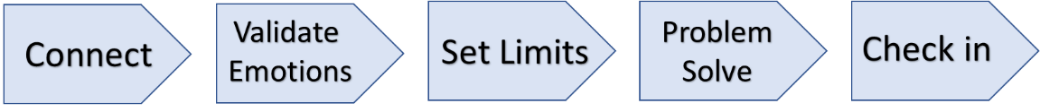

Restorative conversations – See Appendix 3
Being restorative focuses on building positive relationships based on respect and fairness. In turn this creates a community that is supportive, accountable and respectful. The approach is based upon ‘knowing the impact I have upon others.’
For responsibility to be recognised, to repair any harm done, rebuild and restore relationships.
The Restorative Questions:
What happened? Drawing out, each person’s story one at a time, starting with the person who has demonstrated the behaviours/upset. The aim is to get everybody’s point of view so that everybody involved knows they have been fairly listened to.
What do you think and feel about that? Feelings at the time, before and since.
Who has been impacted and how? Who has been impacted and how? Older children are encouraged to think about wider implications of who e.g school, parents, community…
What are the needs of those involved? What do those impacted need to feel better, move on, repair and rebuild relationships?
How can I put this right? What needs to happen next? What action needs to be done to make amends.
What will you do differently next time?

Making Amends.
After any incident, a child needs the opportunity to reflect upon the behaviour demonstrated and the impact it had. This will happen as soon as it is possible and staff will guide children through the above process. It is important that the child should not feel judged and can discuss the incident openly so that it can be avoided in the future. Through emotion coaching and restorative conversations an agreed plan of actions and natural, proportionate consequence will be agreed.
Following regulation strategies, if a child’s behaviour does not improve and disrupts the teaching and learning of pupils within the class, the child will be referred to a phased leader/member of the senior leadership team.

Monitoring of behaviour.
At Rowley Park, we monitor behaviour incidents on a SIMS tracker. The Senior leadership team and pastoral staff will regularly review the number and frequency of incidents recorded so that repeated behaviours and patterns can be monitored and addressed as a team. At weekly phase meetings, staff have the opportunity to raise any concerns regarding behaviour of any pupils in their classes.
We aim to work with parents to achieve a shared knowledge of strategies to enable consistent messages to be shared with children from both home and school. Parents will be kept informed of any ongoing behaviour that is being demonstrated. Our strategies will be shared with parents and support offered where it is required. Parents can request support from the well-being team and we will keep parents informed of any training available through school or the HOPE programme to help children with emotion and behaviour regulation.
The School Well-being Team and those responsible for overseeing behaviour consists of:
Mrs Beaumont – Headteacher
Mrs Smith – Deputy Head, Safeguarding Lead
Mrs Homer – SENDCO
Mrs Mayo – Family Support Worker/HOPE programme
Phase Leaders – Mrs Lord (EYFS), Mrs Smith (KS1), Mr Smith (KS2)
Academy Council – The academy council will be provided with a termly behaviour overview of the school and will be responsible for reviewing and adopting any changes to the behaviour policy. Part of their monitoring councillors will undertake activities in school to ensure this policy feeds into the culture of the school.
Parents should speak to the class teacher regarding any queries or concerns in the first instance.
In more serious incidents a member of SLT will investigate and will involve and work with parents as necessary. Children will be expected to take responsibility for their actions. Where necessary, information may be shared with outside agencies if required (such as in the case of a safeguarding concern.) Examples of more serious incidents include but are not limited to:
- Any form of bullying including online
- Any form of peer on peer abuse including sexual harassment
- Online harassment including unwanted messages and comments, this includes off-site behaviour online.

Behaviour Plans and Exclusions.
If inappropriate behaviour continues over a period of time and the above procedures are not having an impact then an Individual Behaviour Plan may be drawn up and the following actions may occur.
- HOPE programme intervention
- Discussion between teacher/child/parent - agreeing on targets for behaviour
- Family support in regards to
- Seclusion in school
- Child excluded from lunchtimes (If lunchtime related)
- Child reduced to a part time timetable
- Suspension exclusion
- Permanent exclusion

Exclusions
It can only be the Headteacher that can make the decision to suspend or permanently exclude a pupil.
Incidents of extreme behaviour and severe breaches of the behaviour policy can lead to a suspension or permanent exclusion.
Examples of include:
- Intended assault (verbal or physical) on an adult
- Intended assault (verbal or physical) on a child.
- Discrimination, especially on the grounds of race, sexual orientation or disability
- Stolen Items
- Bringing banned items into school (drugs, knives or weapons, alcohol, tobacco items, fireworks, indecent images or any article that the member of staff reasonably suspects has been, or is likely to be used to commit an offence, or to cause personal injury to, or damage to property of; any person (including the pupil). *
- Intended serious damage to property
- Bullying inside and outside of school
- Online bullying inside and outside of school
*Headteachers and staff they authorise have a statutory power to search a pupil or their possessions where they have reasonable grounds to suspect that the pupil may
have a prohibited item listed in banned items without consent.

*Rowley Park Academy has a separate Child on Child abuse policy that runs alongside this policy.

There are three types of exclusion that the school can sanction:
- Lunchtime exclusion
- Suspension
- Permanent exclusion
Lunchtime Exclusion: Pupils whose behaviour at lunchtime is disruptive may be excluded from the school site for the duration of the lunchtime period for a fixed length of time. They should be collected, supervised at returned to school for the afternoon session by an adult.
Suspension: For continued disruptive behaviour, or a serious breach of policy (which are not serious enough to warrant a permanent exclusion), an exclusion of a fixed number of days, for the shortest time necessary will be given.
Permanent Exclusion: This decision can only be taken by the Headteacher.
A decision to permanently exclude will only be taken:
- In response to a serious breach of the school behaviour policy and
- If allowing the pupil to remain in school would seriously harm the education or welfare of pupils or others in the school
A reduced timetable can be negotiated with parents to try to avoid a permanent exclusion. It may also be necessary to involve out of school professionals, such as the Educational Psychologist, Community Paediatrician and the Pupil Referral Service throughout the above processes.
In the case of a suspension or permanent exclusion parents, local authority, academy council and relevant agencies such as social worker, virtual school head would be notified immediately and given relevant information. Rowley Park follows Staffordshire County Council procedures and timelines in the case of a suspension or exclusion.

Reintegration
Following a suspension, the parent will be asked to attend a re-integration meeting where a plan will be shared with the parents and child detailing strategies and approach to successfully integrate the child back into the school environment and routines. The reintegration plan will be decided on an individual basis to meet the needs of the individual child and their family.
https://www.staffordshire.gov.uk/Education/Exclusions.aspx
https://www.gov.uk/government/publications/school-exclusion

This Policy runs in alignment with the following policies:
Child on Child policy
VAT exclusions policy
Anti-bullying
Safeguarding
KCSIE
E-safety
PSHE policy
Positive handling policy.

Appendix 1: Regulation Station
A regulation station is a base within the classroom that children can access when they become overwhelmed or dysregulated to help them calm. The area should contain resources and materials to help the children identify and describe their feelings e.g faces, writing materials, colouring, breathing guidance, mindfulness, a book, talk card, sensory tools ect…
Use of the station should help raise awareness of the need to self-regulate, and promote development independence in identifying and using coping strategies. The station can be used individually, supported by a member of staff or a peer as appropriate.
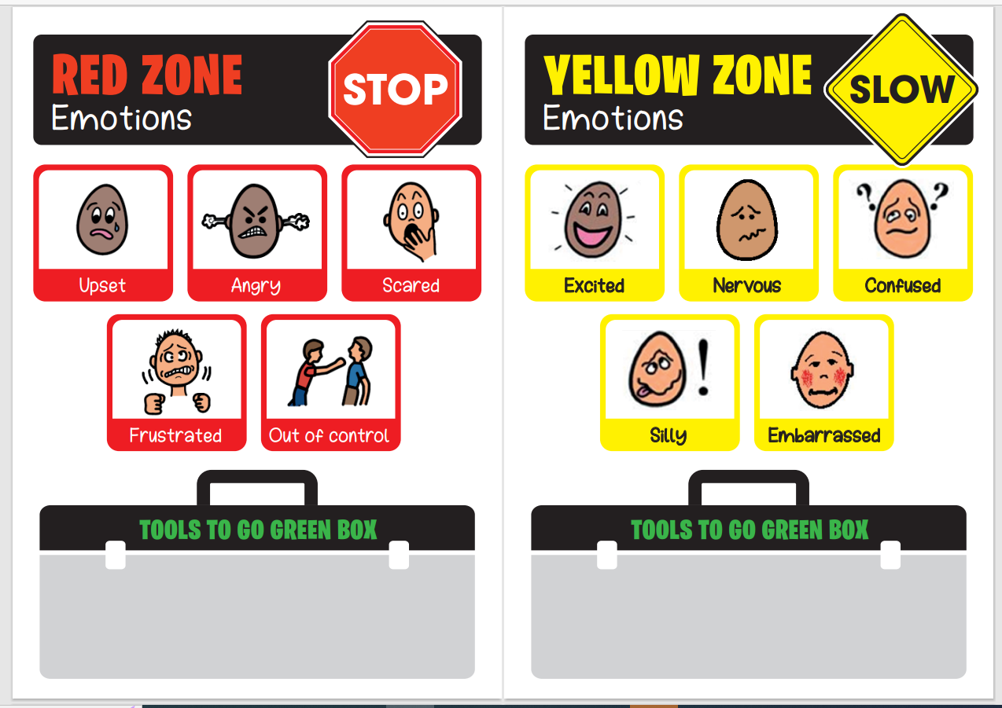
Children will decide as a class the tools they will use and have in place to go green as well as develop awareness of what the emotions look like and sound like. These will be on display.

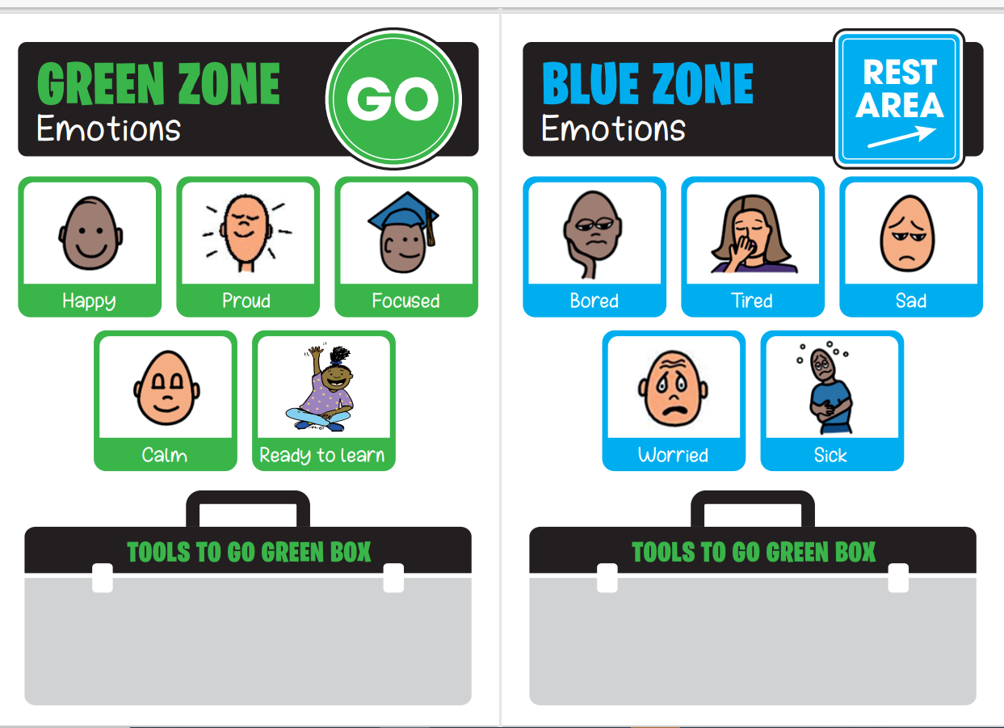

Appendix 2: Emotion Coaching – Steps to help children deal with their emotions.

CONNECT | Remember these:  Listen – Don’t jump to give advice or interrupt  Think – What could the children be feeling? What could I be feeling?  STOP – don’t take the children’s emotions personally, this is an opportunity for connection and practice of self-regulation  Try one or more of these:  Tell me what happened, Encourage deep breaths, Give them space, Draw how you feel, Drink of water, physical activity, Give a simple job, Realisation of Zone (linked to regulation station.)
VALIDATE EMOTION | Help Name Feelings: Are you feeling….or….? What are you feeling? Sounds like you might be? What was that like for you?  Give Fantasy: “You wish that…” “Wouldn’t it be great if…” “Imagine if we could…” “I wish that I could…”  Show Empathy: “Wow that must have been” “That would make me feel” “No wonder you are upset” “I would struggle with that”
SET LIMITS | - Express feelings without attacking –  “I feel …..when I see …..” “It’s ok to feel (emotion), it is never ok to (behaviour)  - State your expectations – I need you to/I expect that  - Give a choice – You can either …………..or …………..  - Help with repair – What do you think should happen now? What would make sense? I wonder if you should? Let’s practice.
PROBLEM SOLVE | Help the child/children problem solve:  What do you need to do right now?  Would you like to do ……… or ………?  What would help you feel better?  What might work if this happens next time?
CHECK IN: | How are you feeling now? – help label the emotion if the child needs you to.  Are you ready to carry on?  Is there anything else you need?  Remind the child who they can speak to should they need to talk about anything.

Appendix 3a: Restorative Reflection Template
Restorative conversation record
Name of pupil |  |  | Class
Referred by |  | Referred to
Date
Outline of situation known:

What happened?
Drawing out, each person’s story one at a time, starting with the person who has demonstrated the behaviours/upset. The aim is to get everybody’s point of view so that everybody involved knows they have been fairly listened to.

What do you think and feel about that? Feelings at the time, before and since.

Who has been impacted and how? Who has been impacted and how? Older children are encouraged to think about wider implications of who e.g school, parents,
What are the needs of those involved?
What do those impacted need to feel better, move on, repair and rebuild relationships?
How can I put this right? What needs to happen next?
What action needs to be done to make amends.

What will you do differently next time?

Appendix 3b
Behaviour Regulation sheet KS 2
My name | Date | Class | Lesson

Reflection Time: Think about what has just happened while you colour.
What did I do wrong?

What feelings did I have and what made me feel like this?

What could I have done differently?

Who might my actions affect?

What can I do to put things right?

Agreed Consequence

Appendix 3c
Behaviour Regulation sheet KS 1
My name | Date | Class | Lesson
What did I do wrong? (Draw a picture of what I did wrong)

What did you feel? (circle the face)
What made you feel that? (Draw it)

How are you feeling now? (Circle the face)
Who did my actions affect? Myself Classmates Teacher others
What do I need to do to put things right? Say sorry Tidy up follow instruction
Agreed Action/consequence:
Appendix 3d
Reflection sheet EYFS
Draw a picture about what happened.

Angry sad worried
What I must do now (after talking with my teacher).

Appendix 4: Behaviours
Behaviours | What might happen?
Green Behaviours:  Demonstrating our school values  Demonstrating or Be Ready, Be respectful, Be safe principles  Improved behaviours  Improved attendance | Positive praise/Verbal Recognition/ I notice that..  Proximity praise  Positive communication (verbal/body language and gestures)  FIDES awards  Dojo points  Merit Awards  Postcards home  Responsibility  Visits to phase leader or Headteacher
Yellow Behaviours:  Displaying overwhelming emotion  Not on task or avoiding work  Disrupting others – shouting out, tapping on the table, getting out of seat  Not following instructions  Poor choices or actions on the playground – not following Be ready, Be safe, Be respectful | Use of the regulation station to help them self-regulate (may need adult support)  Emotion Coaching  Reminder of expected behaviour with so that  Informal restorative conversation  Natural consequence – apology, catching up with work, moving seats,
Orange Behaviours:  Struggling to regulate emotions on their own.  Continue to display the above behaviours  Repeatedly disrupting the teaching and learning of others.  Intentionally being unkind towards another child or staff member  Not accepting intervention to help make good choices  Being rude  Inappropriate language or conversations  Conflict with others | Adult and Child collaborative approach:  Emotion coaching away from the classroom.  Individual Restorative conversation with teacher or SLT  Paired or group restorative circle  Call to parents if required  Decide on how to make amends and/or natural consequence for actions shown – apologise, write a letter, tidy up any mess made etc…
Red Behaviours:  Repeatedly doing the above behaviours  A pattern of repeated behaviours on the behaviour tracker.  Bullying including online  Racism/homophobic/sexualised language, harassment or actions including online  Intended physical harm to another person  Behaviour is a danger to themselves of others. Extreme one-off breaches of the behaviour policy | Adults will make the decisions now:  SLT support  Discussion with parents or Carers  Positive Handling techniques (trained staff)  Hope Intervention  Reflective time outside of the classroom with a member of SLT (Internal Exclusion)  Formal Restorative  Fixed term Exclusion  Permanent Exclusion

