Rowley Park Primary Academy

Covid Outbreak Contingency Plan September 2021

When should my child self-isolate or miss school?  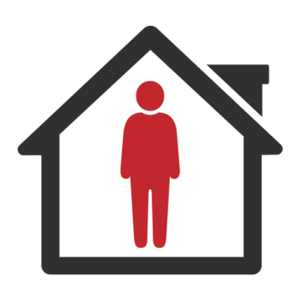 | NO | - All children MUST attend school unless they are ill.  - From 16th August 2021, children under 18 (or double-vaccinated adults) do not need to self-isolate or miss school if a member of their household or a contact, has Covid.  - Instead, they will need to book a PRC test but can continue coming to school so long as they have no symptoms and the test result is negative.
 | YES | - If your child develops Covid symptoms at home, they should stay at home and should book a PRC test), NOT a Lateral Flow test.  - If your child develops Covid symptoms at school, they will be sent home and you should book them a PRC test.  - If your child tests positive for Covid, they will need to self-isolate. The rest of the household does not need to self-isolate if they are under 18 or fully vaccinated – but instead should book a PRC test.

Community  Covid Risk | Description | Actions
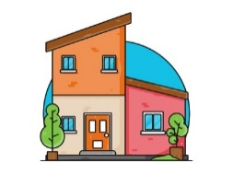  Low Community Transmission. No School Cases. | - There have been no cases of Covid within school for 10 school days.  - Cases of Covid locally are low and/ or stable.  - Hospitalisation/ Deaths due to Covid nationally are low. | No Covid measures are necessary beyond:  - Reminding children of good hand-hygiene.  - Ensuring good ventilation encouraged where practical.  - Ensuring Children / Staff to stay at home if they have Covid Symptoms (and to book a PCR test).  Staff will continue to test themselves using Lateral flow tests until the end of September.
Rapidly Rising Community Transmission | - No current Covid cases have been recorded at school, but…  - Cases of Covid are rising rapidly in the community causing disruption to other local schools.  - Local Public Health / Public Health England issue warnings of expected local/ national infection wave. | - Ventilation of classrooms increased & hand-washing supervised.  - Large indoor public performance audience numbers reduced.  - Staff-room capacity is reduced.  - Whole-school assemblies are replaced with Key Stage assemblies.  - Clinically Vulnerable staff meet with Line-Managers to review their individual risk assessment & discuss additional protection (e.g., use of face coverings, reduction in movement between classes/ groups).
Number of Cases: | Description: | Actions:
A single child tests positive | - A single child tests positive for Covid in a class.  - There are fewer than 5 cases or 10% in the class/year group (classed as contact group)  - No other year groups/classes are affected. | - The child self-isolates for 10 days. Remote learning will be provided if they are well enough to complete it as outlined in our remote learning plan.  - The parents of the child are contacted directly by NHS Track and Trace to establish likely contacts.  - Likely contacts will be contacted by NHS Track & Trace and advised to book at PRC Test. The school will contact parents to advise this if close contacts are known.  - Children do not need to miss school or self-isolate whilst they wait for the result of the PRC test unless they have Covid Symptoms.
5 children or staff / 10% of children in a bubble test positive within 10 days of each other  OR  3 children or staff / 10% of children in a single Class / Club  (or Resource Base) within 10 days. | - There have been 5 cases or 10% of Covid cases across a class/year group (contact group) within 10 days which could mean that Covid is spreading within that group of children. | - As above for each positive case.  - The school will discuss the outbreak with Local Public Health and agree strengthening protective measures for 10 school days, including:  - Re-introducing staff face masks for corridors & communal areas.  - Adapting, Limiting or postponing indoor sporting events, trips, open days and performances.  - Reverting to video-link Assemblies in classrooms.  - Reducing the amount of classes staff work across.  - Consider bringing back bubbles to reduce contacts  - Resuming twice-weekly Staff Lateral flow testing.
Covid cases continue to increase rapidly within a 10 day period. | - Despite the measures indicated above, Covid cases within the school continue to rise within a 10 day period with multiple classes and staff affected, suggesting that Covid is spreading widely throughout the school. | - Incident Management Team meeting held between the school and Local Public Health to agree further measures, for a further 10 school days, including:  - Re-introducing class bubbles.  - Reverting to class-based school lunches.  - Limiting all non-essential visitors to school.  - Postponing all non-essential events.  - Re-introducing remote learning for individual classes for 10 school days considered, as outlined in school’s remote learning plan.

The school will inform parents of any changes to Covid measures should these be needed via normal written/electronic communication methods.

