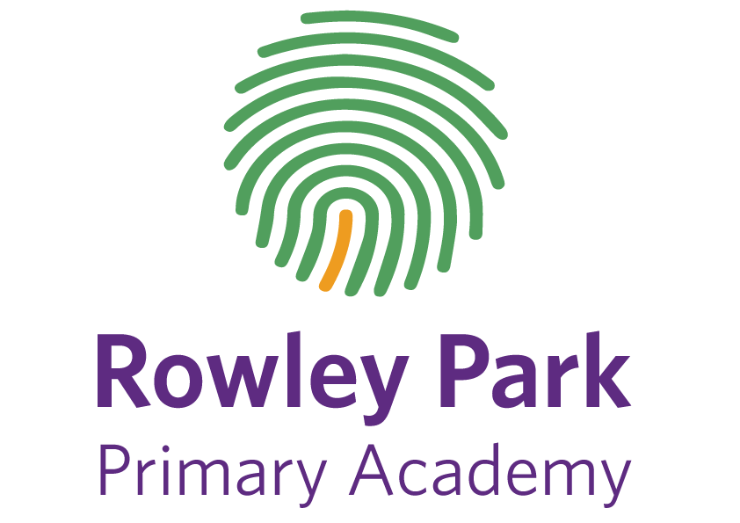
Pupils Remote Learning Code of Conduct

When learning on-line – just like when we are at school – our FIDES values are important.
The following code of conduct will help us continue to learning and uphold our values.
I will:
✓ arrive on time to all my online lessons and wearing something suitable
✓ have everything that I need ready for the lesson – pen, pencil, paper, books.
✓ keep my microphone muted unless the teacher asks me to speak, and mute myself when I have finished (if I don’t know how my teacher will help me).
✓ under no circumstances record the lesson, or share any images from the lesson on any social media platform.
✓ stay focused on my lesson (and not have things around to distract me from my work)
✓ arrive on time to all my online lessons and wearing something suitable
✓ join my teacher ‘drop in’ in when I need some support
✓ follow my teacher’s instructions.
✓ complete my tasks as well as I possibly can and share them with my teacher (on Showbie/Tapestry). My teacher can then give me feedback about my learning.

