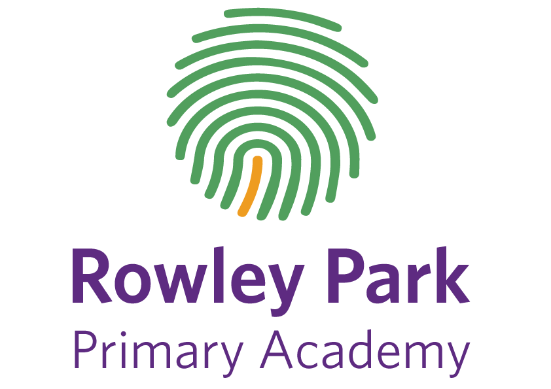
Parent Remote Learning Code of Conduct

When pupils are learning remotely, they will join some ‘live’ lessons. Their teachers may be streaming the lesson from school or from another location, depending on the circumstances. Our expectation is that pupils continue to follow the full curriculum and engage with all their learning; live lessons, videos and learning tasks, guided group reading.
We expect pupils to uphold our FIDES values, behave respectfully and work hard, just as they do when they are in school. We value your support in ensuring that your child learns safely and helps to keep others safe.
Parents are expected to support their child in this.
As a parent/carer I will:
✓ ensure, as far as possible, that my child can access their online lessons in a quiet environment and appropriately dressed
✓ support my child’s personal organisation so that they attend lessons punctually and have what they need.
✓ where possible, be situated where I can see/hear my child’s online lessons.
✓ encourage my child to participate fully in online lessons and to complete independent work set
by the teachers.
✓ ensure that no element of an online lesson is recorded by my child, myself or family members
✓ not try to communicate with the class teacher during an online lesson as this will disrupt the
learning of all pupils in the class.
✓ avoid making any comments, or sharing any material, on social media that could identify my
child, their school or staff.
✓ ensure that my child takes care of any equipment that they have been loaned by the school and
uses it only for the intended purposes.
✓ report any concerns that I have about my child’s learning with appropriate staff at the school.

