**Reception**

**News**

**Autumn 2020**

Reception Staff

It has been an unusual start to the school year but as a staff we are very proud of how Reception class have settled into the routines of school. Staffing for Reception this year is Mrs Lord (Teacher) Miss Lea (Teaching Assistant AM) and Miss Spear (Teaching Assistant PM). We are all looking forward to working with your children and watching them all grow over the rest of the year.

**Rowley Park Primary Academy**

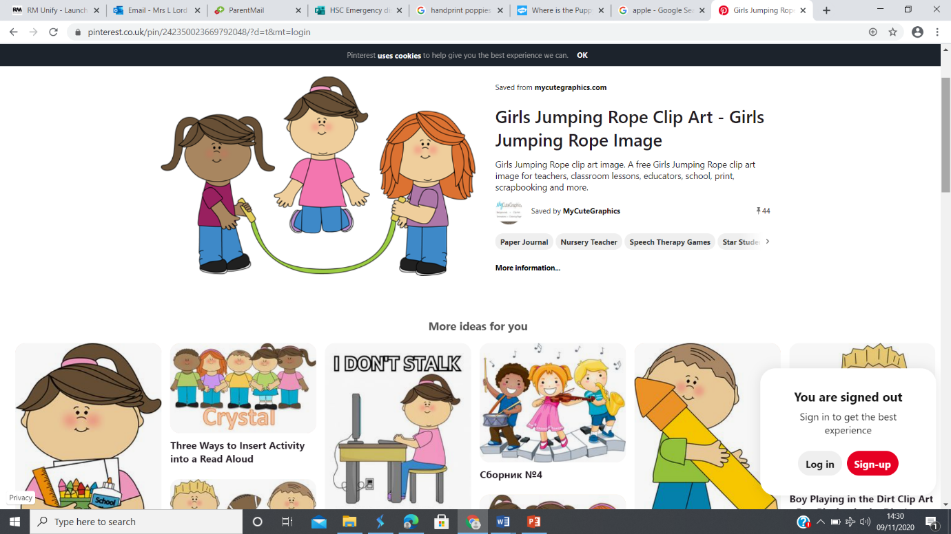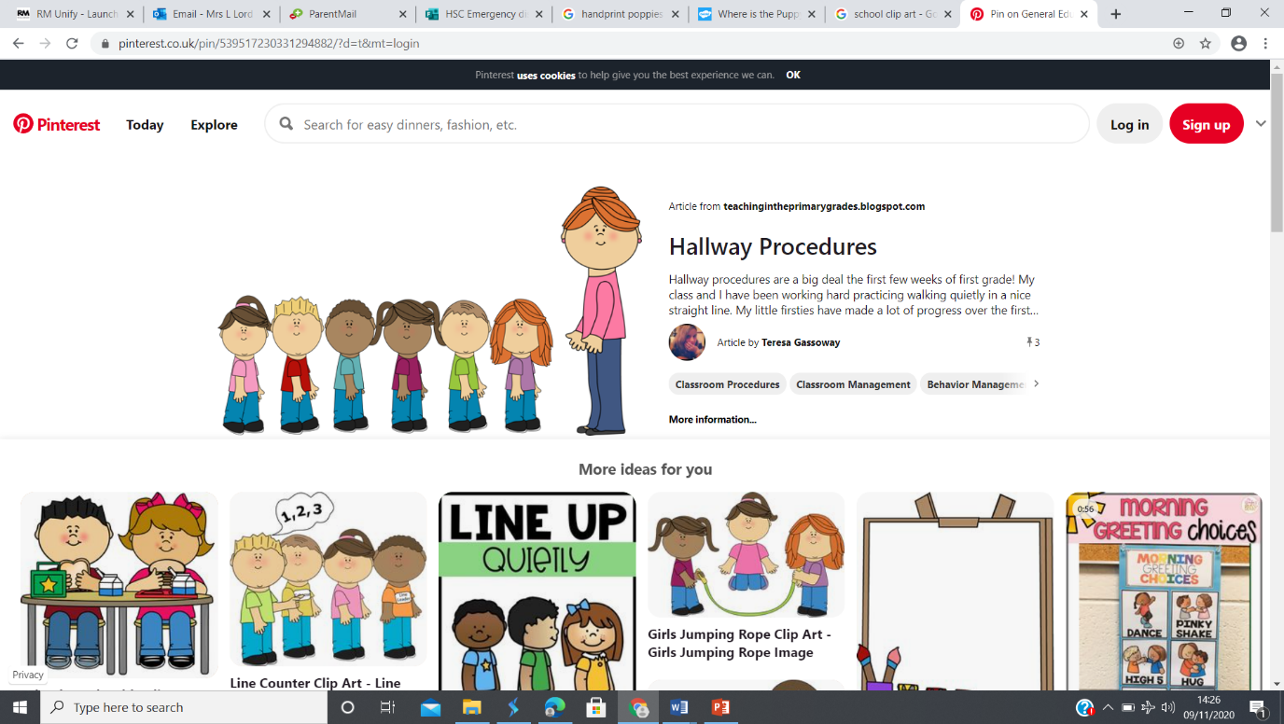

Parent Contact

Although contact is limited at the moment if you do need to speak to me please call the school office and use Tapestry to post things that the children are doing at home.

You can also find out about what the children are doing in the classroom on Twitter

@LauraLord35

@aspear_

@HeidiLLea

Homework – Little and Often!

Thank you to all of the parents who are completing the homework with their children it is also lovely to see what they are getting up to at home!!

Please continue to read as much as you can with your child at home, a love of reading is so important and has an impact on many other areas at school.

Little and often is a good approach with this age group and 5-10 minute slots when reading school reading books at home it perfect. Please complete the yellow reading record and if you need any support in how to support your child with this vital skill please just ask.

Dates

For date please see the Headteachers newsletter for up and coming dates.

Accidents will happen!!!

Please ensure that your child has at least one change of clothes in school.

Any parents that have spare pants, trousers and skirts that they can donate to school would be very much appreciated.

Uniform

Please could you ensure uniform is named as it is very difficult to make sure children go home with the correct jumpers and cardigans.

Our Learning Journey

Our theme this half term is ‘Let’s Celebrate’ and our challenge is to create a performance for an audience. Through this challenge pack we will look at different celebrations around the world and explore other cultures and festivals as well as the ones they celebrate with their own families.

In Maths we will be focusing on recognising numbers to 20 and adding and subtracting practically.

In phonics the children will continue to increase their knowledge of letters and sounds and using these when reading and writing.

If you have any questions about your child’s learning or how best you can help at home, please contact me via the school office or Tapestry.