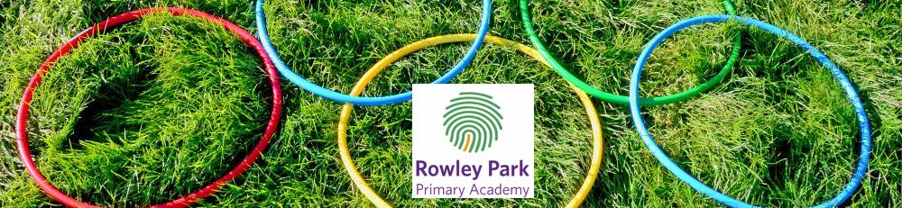

Dear parents,

Hope you are all keeping safe and well, normally at this time of year we would be gearing up for Sports Day. As you are all aware, with pupils at home and some children at school we have decided a way we can still compete and have fun is by completing our Sports Day virtually.

The Virtual Sports Day will actually become a Virtual Sports Week, where pupils will be set 10 different sporting challenges and they will have a full week to complete as many as they would like.

Virtual Sports Week will commence on Monday 13th July. On the Home Learning Portal in the Virtual Sports Week folder, there will be a launch video, 10 different challenges with a video demonstration and a link to a Google Form document.

At the end of the week or when your child has completed the challenges, complete the Google Form document, which will inform how many of the challenges have been completed. Following this, the team colour, which completes the most challenges will be the winner!

We would love to see lots of you getting involved and remember to tweet in any photos or videos to @RowParkAcademy using #RPAVirtualSportsWeek.
Thank you and good luck!

Mr Hunt.

