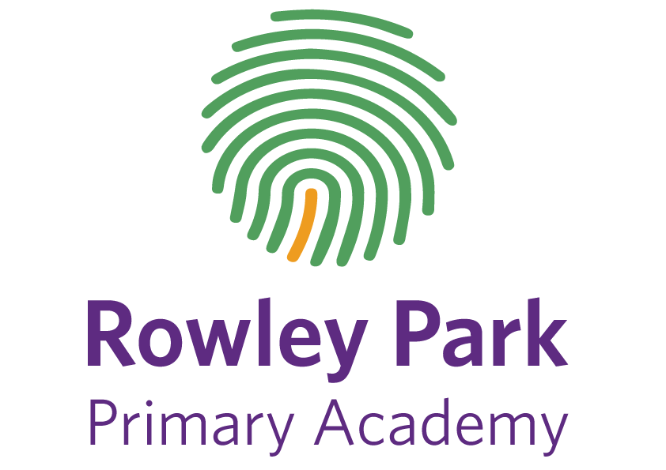

Rowley Park Academy
Nursery Application Form
Child’s details

Child’s legal full name:

Date of birth:

Child’s Address:

Is your child a twin/multiple birth? Y / N

Is the child in the care of the local authority? Y / N

Does your child have a statutory statement of educational need or Education, Health and Care Plan?

Details of person completing this form

Parental Responsibility? Y / N

Relationship to Child:

Full Name:

Address: (if different)

Contact Number:

Email Address:

Hours Required

Will your child receive funding for:

15 hours free Nursery Education

30 hours free Nursery Education (working parents – evidence of award required).

Signature: Date:

